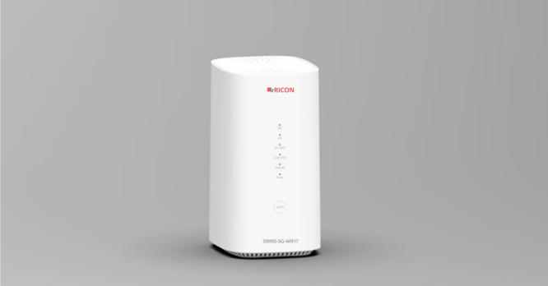

Product Overview
The S9055-5G-WIFI7 is a new, high-performance WiFi 7-enabled 5G CPE brought to market by Ricon Mobile Inc. Using the latest Samsung chipset for its cellular solution, the product features a WiFi architecture based on the 802.11be standard and houses a 2x2+2x2 entry-level dual-band WiFi configuration. It combines strong cellular performance with a high cost advantage. The product is fully compliant with the 3GPP R16 protocol standard; besides supporting different network types including NR-SA, NR-NSA, FDD-LTE and TDD-LTE, it offers strong carrier aggregation capabilities. Essentially, by converting cellular network access into WiFi and wired connections, it provides network access for various end devices such as smartphones, tablets and personal computers, and can support numerous service types. With its plug-and-play architecture, this device requires no extra setup and has a wide range of uses across different scenarios such as homes, street-front shops, and small and micro businesses.
.

Product Features
High-Speed Internet Experience | This device supports the common frequency bands used worldwide, is compatible with both 5G SA and NSA networks, and supports bandwidths of up to 200M on 5G networks, delivering an excellent 5G internet experience to users.  Under an SA network, the device supports 5CC carrier aggregation; under an NSA network, it supports a rich set of ENDC combinations, delivering maximum download and upload speeds.  Under an LTE network, the device can support up to 6CC downlink carrier aggregation and 2CC uplink carrier aggregation, delivering outstanding uplink and downlink speeds even on a 4G network.
Latest WiFi 7 Standard, Dual-Band Concurrent Connection | This device supports the latest WiFi 7 standard, offers 2.4GHz and 5GHz dual-band support, supports 2x2 MIMO technology with 160M ultra-wide bandwidth, and reaches theoretical speeds of up to 3600Mbps, delivering an ultra-high-speed WiFi access experience to users.  The device uses OFDMA technology, which allows it to transmit data packets to multiple terminal devices simultaneously; combined with MU-MIMO technology, it supports multiple terminal devices accessing and using services at the same time.  The latest Multi-Link Operation technology allows a single STA device to connect to the CPE over multiple bands simultaneously, which greatly increases throughput and reduces latency.
Multiple Network Options and Multi-Service Support | The product supports mobile cellular and/or wired broadband as uplink, and also supports WiFi and/or LAN ports for terminal device access. Network setup is much more flexible.  The device is also equipped with an RJ11 voice interface. When paired with a phone, it can support voice call services over VoLTE/VoNR. Multiple services such as internet access, video streaming and voice calls can be carried out simultaneously, meeting a wide range of user needs.
High Availability with Dual-Link Uplink | The product supports configuring both cellular and wired uplink connections at the same time. Users can set link priority and detection criteria. When the primary link is disconnected, the device can automatically switch to the backup link, which significantly increases the device's high availability.  The device supports self-healing. In the event of a cellular network fault causing a network outage, the device automatically reconnects and restores the network connection once the network recovers.
Device Protection Against Theft and Misuse | The device can be customized for use with specific PLMNs, thereby protecting operators' rights and interests.  Supports 5G frequency band and cell locking functions. The device becomes unusable when taken outside its designated deployment area, which protects the equipment and prevents it from being used for other purposes.  The device supports different administrator accounts and authorization levels that can be customized according to operator requirements.

Hardware Features
CPU | Realtek Dual-core ARM Cortex-A55 @1.2 GHz and Tri-core RISC-V @800 MHz for WiFi Offload
Memory | DDR: 512MB  Nand Flash: 128MB
Cellular Chipset | Samsung S5300
WiFi Chipset | Realtek
Cellular Features
3GPP Compliance | Rel-16
Supported Technology | 5G NR NSA & SA: Option 3x/3a/3 and Option 2 4G LTE: TDD & FDD  3G UMTS: WCDMA
UE Category | LTE DL Cat 20, UL Cat 18
MIMO | NR: DL 4x4, UL 2x2 LTE: DL 4x4
Carrier Aggregation | NR CA: DL 5CC 200M; UL 2CC 200M  LTE CA:DL 6CC 120M; UL 2CC 40M
Theoretical Peak Rate | NR SA: 4.67Gbps DL/1.25Gbps UL NR NSA: 6.47Gbps DL/730Mbps UL  LTE: 2.0Gbps DL/211Mbps UL
Cellular Antennas | 4 internal Omni-Directional antennas
SIM Support | 1 * nano SIM  1 * eSIM (Optional)

WiFi Features
WiFi Protocol | 2.4 GHz: IEEE 802.11 b/g/n/ax/be 5 GHz: IEEE 802.11 a/n/ac/ax/be
MIMO | 2.4 GHz: 2x2 MIMO  5 GHz: 2x2 MIMO
WiFi Bandwidth | 2.4 GHz: 20/40 MHz  5 GHz: 20/40/80/160 MHz
Theoretical Throughput | Total theoretical WiFi throughput: 3600Mbps  2.4GHz: 688Mbps (2ss 40MHz)  5GHz: 3600Mbps (2ss 160MHz)
WiFi Antennas | 2.4 GHz: 2 internal Omni-Directional antennas  5 GHz: 2 internal Omni-Directional antennas

Interfaces, Buttons and Indicator Features
WAN Port | 1 * 2.5GE port,100M/1000M/2500M adaptive, type:RJ45
LAN Port | 3 * GE ports,100M/1000M adaptive,type:RJ45
Voice Port | 1 * FXS VoLTE/VoNR port (optional), type: RJ11
USB Port | 1* USB2.0
Power Supply Port | 1 * DC-Jack port
Other Port | 2 * TS9 ports, for external 5G antenna connection
pSIM Interface | 1 * SIM slot 4FF (nano SIM)
Indicators | 1 * 5G (Green / Yellow / Red)  1 * 4G (Green / Yellow / Red)  1 * WiFi (Green)  1 * Phone or Internet (Green)  1 * System (Green)  1 * Power (Green)
Buttons & Pinhole | 1 * Power On/Off button  1 * Reset pinhole  1 * WPS button

Physical Features
Dimensions | 95mm*114mm*186mm (L*W*H)
Weight | 700g
Material | ABS Housing IP30
Color | White
Installation | Tabletop

Power Module
Power Supply | Power adapter (Input: 100~240V, 50/60Hz)
Output Voltage | DC 12V
Output Current | DC 2A
Power Consumption | Max 24W

Environmental Parameters
Operating Temperature | -10℃ + 45℃
Storage Temperature | -20℃ + 70℃
Operating Humidity | %5 - %95 (non-condensing)
Storage Humidity | %5 - %95 (Non-condensing)
Protection Class | IP30

Software Features
Status Management | System Status / Device Information  Mobile Network Status  WAN Status  LAN Status  WLAN Status  TR069 Status  Web GUI  CLI / Telnet / SSH  SNMPv2  SIM Lock, Band Lock, Operator Lock  Traffic Statistics
Mobile Network | APN Management  PIN Code Management  Network Mode Selection  Mobile Data Switch & Roaming Switch  Short Message Service  Band Lock  Cell Lock  VoLTE/ VoNR  Mobile Network Self-Recovery
WAN Configuration | Operating Mode: Routing mode, Bridge mode IPv4, IPv6, IPv4/IPv6  PPPoE, DHCP Client/Server  DNS, Dynamic DNS  Uplink WAN mode: Cellular, Wired, Link-backup
LAN Configuration | DDHCP Client/Server  NAT/NAPT  ALG  Virtual Server (Port Forwarding)  MAC Management  IGMP Snooping*  IGMP Proxy*
WiFi Configuration | Basic Settings (SSID, password, etc.)  Advanced Settings (protocol, BW, channel, etc.)  Cipher Mode (OPEN/WPA/WPA2/WPA3)  WiFi Protected Set-up  Multiple SSID  Band Steering  Guest WiFi  STA Management  Mesh Settings
Routing | Static routing v4/v6
VPN Protocol | L2TP/PPTP  IPSec  VxLAN
Security & Firewall | Basic firewall  Anti-attack (ARP, DDoS, etc.)  Anti-scan  Port filtering  MAC filtering  DMZ
Additional Functions | UPnP  Parental Control
Device Management | Cloud Management Platform (Optional)  Language Management  User Management  Firmware Update & Rollback  Remote Management: TR069/XMPP*/SNMP FOTA  Reboot, Factory Reset  NTP Management  Configuration Export and Import  Diagnostics

Application Topology

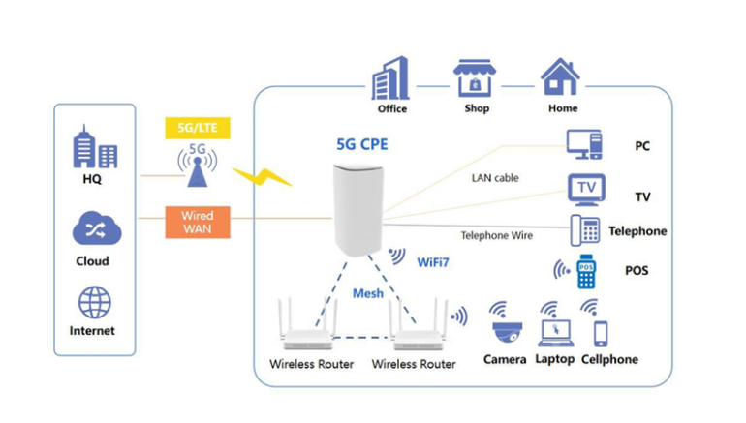

Model Information
Model | S9055-5G-WIFI7
Chipset | Samsung S5300
Applicable Region | EMEA  Asia Pacific
Supported Bands | 5G NR:n1/n2/n3/n5/n7/n8/n20/n26/n28/n38/n40/n41/n66/n67/n71/n75/ n76/n77/n78  LTE-FDD:B1/B2/B3/B4/B5/B7/B8/B20/B26/B28/B32/B66/B67/B71  LTE-TDD:B38/B40/B41/B42/B43/B46/B48  WCDMA:B1/B2/B3/B5/B8

Product Views

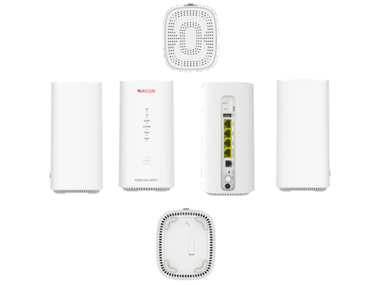

Revision History
Version | V.0.1.02
Date | August 2026
Description | Preliminary version prepared for product description only

About Ricon

At Ricon, we create technologies that make communication easier.
As a 24-year-old B2B technology innovation company, we design networks that sense, think and act across mobile, fixed and cloud networks.
Service providers, businesses and partners around the world trust Ricon today to deliver secure, reliable and sustainable networks, and work with us to create the digital services and applications of the future.

© 2026 Ricon
Ricon Canada Office (HQ)  5063 North Service Road  Burlington Ontario L7L 5H6  Canada  riconrequest@riconmobile.com  +1 (905) 921-3122  +1 (905) 336-2450 | Ricon Turkey Office  Ahi Evran Cad. No: 21  Polaris Plaza Floor: 6-8  Maslak, Istanbul  riconturkiye@riconmobile.com  +90 212 346 26 00 | Ricon Turkey Office ITU  Reşitpaşa Mah. ITU ARI 3  Teknokent No:4-Z101  Sarıyer, Istanbul  riconturkiye@riconmobile.com  +90 212 346 26 00 | Ricon Italy Office  Ricon Italy Office  Ricon Mobile Italy Srl  Via Gaetano Negri 8  20123 Milano Italy  riconitaly@riconmobile.com  +39 335 195 06 86

