S9980DSL-LTE

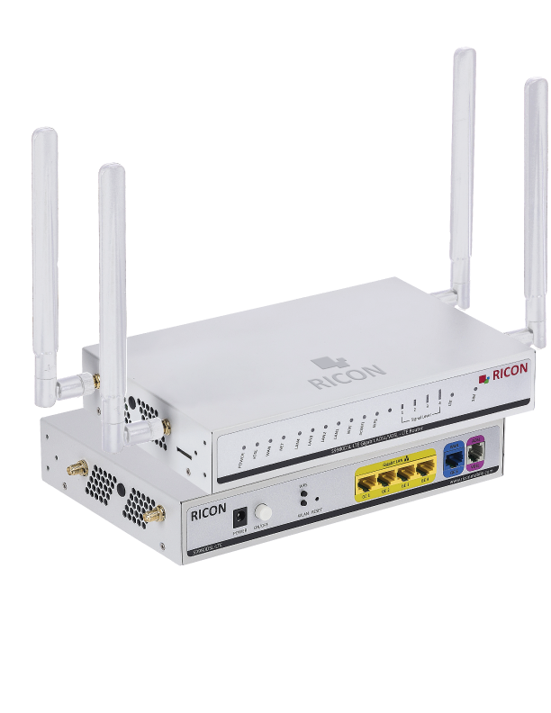

Features  - LTE / 4G / 3G support  - Failover/Failback  - IPSec VPN  - OpenVPN  - WireGuard  - GRE Tunneling  - Firewall  - MAC / IP Filter  - DoS/DDoS Protection  - HTTPS / SSH Connection  - Static & Dynamic Routing  - BGP  - VRF / VLAN  - NAT / Port Routing / DMZ  - DHCP Server / Client  - Bridging / Passthrough  - Policy-based Routing (PBR)  - Web GUI (HTTPS)  - CLI (SSH / Telnet)  - OTA Software Update  - Cloud Management Platform (Optional)  - WPA2 / WPA3  - MAC Filter  - WPS / Wi-Fi Scheduling  - Gigabit Ethernet ports  - Connection timers  - Task definition via scripts | Technical specifications  Dimensions and weight  - Height: 40mm  - Width: 230mm  - Depth: 150mm  - Weight: 784g  Environmental  - Idle: 80mA + 12VDC  - Single Module Power Consumption: <7W  - IP54 Protection  - Operating Temperature −30…+70 °C  - Storage Temperature −30…+85 °C  - Humidity <%95 (non-condensing)  Certifications  - Industry Canada, PTCRB, CE, FCC, UL, E57, RoHS  - EN 62311  - EN 60950- 1+A11+A1+A12  - EN 301-489-1/-7/-17/-24, EN 55022, EN 55024  - EN 301 511, EN 301 908-1/-2, EN 300 328

General features
CPU | RTL8685PB MIPS 32Bit
Memory | 64MB
HW Watchdog | Connection timers  Ping / Uptime Watchdog  Script tasks
SPI Flash | 128MB
Module | Quectel EC25-EC Module
Interfaces and Configuration
LAN | 4x1000 Mbps
WAN | 1× 10/100/1000 Base-T RJ45
DHCP Server | DHCP Server/Client/Relay, DNS

Cellular Features
Cellular Modem Module | EC25-EC
Module Type | MINI PCIe
Region | Global
Chipset | Qualcomm MDM9207-1
Category | LTE: Cat.4
Cellular Bands (SDX62) | 4G LTE: B1 / B3 / B7 / B8 / B20 / B28A  3G UMTS/WCDMA: B1 / B8  2G GSM: B3 / B8
SIM Support | (U)SIM
Security Features
Firewall | Identity-Based Firewall  Identity-Based Firewall  DoS
Filters | Access restriction  Restrict wireless access
Misc | Security logging  Packet capture logging (pcap)

Management Features
Management Interfaces | Web GUI (HTTPS)  CLI (SSH / Telnet)  SNMP  Syslog / Event Log  OTA Firmware Update  Cloud Management Platform  SSH  SNMPv2  TR-069
Version Management | Image Checksum  Active version and backup version  Automatic rollback feature when remote upgrade fails
Account Management | TACACS/TACACS+, Radius Auth.
Retrievable Parameters  WEB UI / CLI / TR-069 / SNMP | CLI command line access  SNMP remote monitoring and management  Web-based graphical interface management

Cellular Modem Features
APN Data Services | Dynamic APN support  SIM PIN management  Bridge Mode Support
Modem Interface Configuration | SIM slot selection  Full band scan  Modem Band Lock  Automatic/On-demand dialing  Radio Enable/Disable  Pppd and DHCP dial options
Modem Backup | Via interface

Wi-Fi
Chipset | Realtek RTL8812FR
Wi-Fi Features | Wi-Fi Radio: 2.4 GHz, up to 80 MHz  Wi-Fi Standards: IEEE 802.11 a/b/g/n/ac (Wi-Fi 4 and Wi-Fi 5)  Channel Bandwidth Support: 20/40/80 MHz  2.4 GHz Maximum Data Rate: 300 Mbps (2×2 MIMO, 40 MHz)
MIMO | 2.4 GHz: 2×2 MIMO
Region | Global
Wireless Security | Protocols: WEP, WPA, WPA2, WPA3  Encryption: AES, TKIP
Mode | Access Point (AP) and Wi-Fi Client (Station/Client) modes are supported

Network Features
Routing | Static Routing, Dynamic Routing  BGP  OSPF / RIP  VLAN  NAT / Port Forwarding / DMZ  DHCP Server / Client  Bridging / Passthrough  Policy-Based Routing (PBR)
Tunnels | IPSec VPN  WireGuard  OpenVPN  L2TP  PPTP  MPLS  GRE Tunneling  Firewall  MAC / IP Filtering  DoS Protection  HTTPS / SSH Access
Routing | NAT Support  Port Forwarding  DMZ Support
Load Balancing | Per-Packet Routing Support
Ordering Information and Accessories
S9980DSL-LTE | CAT4 Cellular Radio Interface  4xLAN Gigabit, 1xWAN Gigabit, SIM Slot  xDSL  2.4 GHz, 5GHz Wi-Fi 802.11b/g/n/ac
Defaults
Box Contents | S9980DSL-LTE  2 x 3m LTE antenna  2 x 2.4 GHz, 5GHz WiFi antenna  1m CAT6 cable  Mounting kit  12 VDC 1.5 A Power Adapter

About Ricon

At Ricon, we create technologies that make communication easier.
As a 24-year-old B2B technology innovation company, we design networks that sense, think and act across mobile, fixed and cloud networks.
Service providers, businesses and partners around the world trust Ricon today to deliver secure, reliable and sustainable networks, and work with us to create the digital services and applications of the future.

© 2026 Ricon
Ricon Canada Office (HQ)  5063 North Service Road  Burlington Ontario L7L 5H6  Canada  riconrequest@riconmobile.com  +1 (905) 921-3122  +1 (905) 336-2450 | Ricon Turkey Office  Ahi Evran Cad. No: 21  Polaris Plaza Floor: 6-8  Maslak, Istanbul  riconturkiye@riconmobile.com  +90 212 346 26 00 | Ricon Turkey Office ITU  Reşitpaşa Mah. ITU ARI 3  Teknokent No:4-Z101  Sarıyer, Istanbul  riconturkiye@riconmobile.com  +90 212 346 26 00 | Ricon Italy Office  Ricon Italy Office  Ricon Mobile Italy Srl  Via Gaetano Negri 8  20123 Milano Italy  riconitaly@riconmobile.com  +39 335 195 06 86

